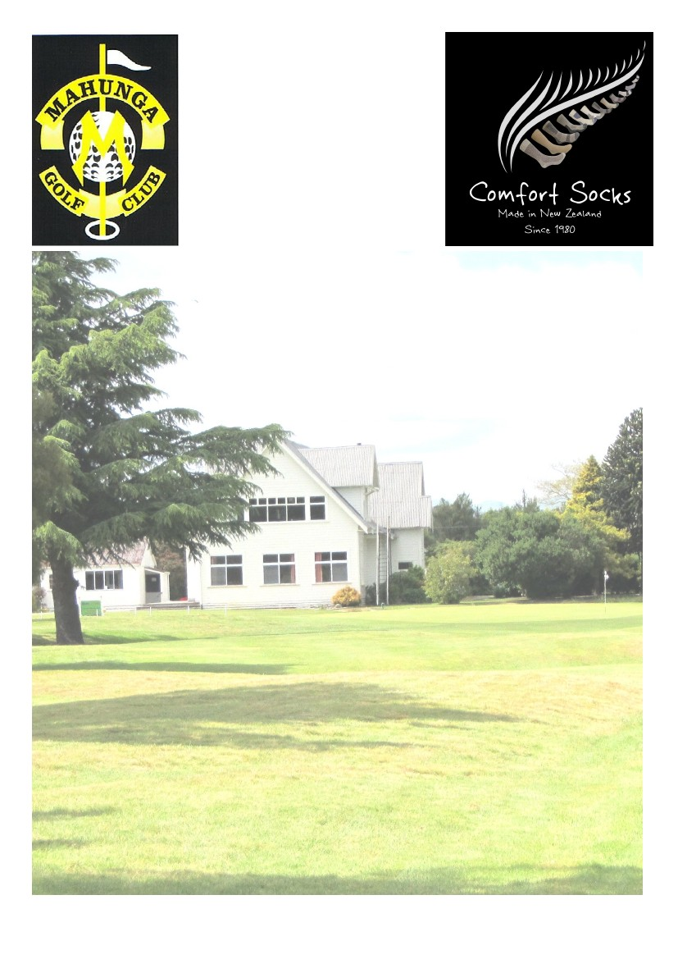

**Entry Fee - $60.00**

INCLUDES 2’S, NEAREST TO PINS & LONG DRIVES

COURTESY COACH AVAILABLE

**ENTERTAINMENT—SUNDAY EVENING**

**MEAL AVAILABLE SUNDAY EVENING**

**COOKED BREAKFAST AVAILABLE**

**SATURDAY & SUNDAY FROM 8am TO 10am**

**SATURDAY 20th APRIL & SUNDAY 21st APRIL 2019**

**PRACTICE DAY FRIDAY 19th APRIL**

**GROSS & NETT COMPETITION**

**MEN’S AND LADIES GROUPS**

**TEE OFF 9 TO 11.30AM**

**EASTER TOURNAMENT**

**MAHUNGA GOLF CLUB MASTERTON**

**&**

**COMFORT SOCKS**

**NEW ZEALAND LTD**

WWW.COMFORTNZ.COM

Entries To: Mahunga Golf Club

mahungagolfclub@gmail.com www.mahungagolf.com

Organiser: Layton Kawana Phone 027 207 4201 Layton.kawana@gmail.com