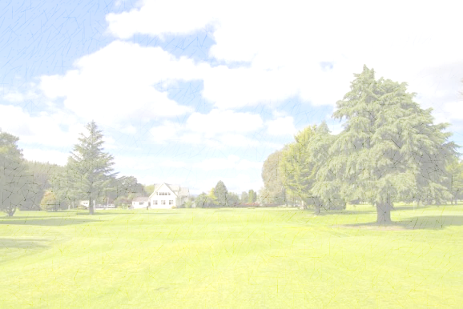
Headstones Wairarapa Twilight Golf Mahunga
Open to anyone with or without a handicap
11 Hole Competition
Tuesday Evenings at Mahunga Golf Club
4 Person Ambrose Nett
Tee off between 4pm and 6pm
Best 6 of 8 rounds
Starts: 23rd Oct
Ends: 11th Dec (with Pizza and prize-giving after play)

Entry Fee - $30 per player - (covers all 8 rounds and 2’s – please pay on first day in cash!)
For handicapping – The lowest 3 handicaps divided by 10 and these will be adjusted as the comp progresses.
Maximum handicap for any player will be 27
There will be a separate competition for holes in 2. This is $2/team per round and if not struck, will jackpot. Prizes for these are scratchies.

Enquiries/Registration: Tania - 027 8018918 or Mahungagolfclub@gmail.com

